# Current Activities

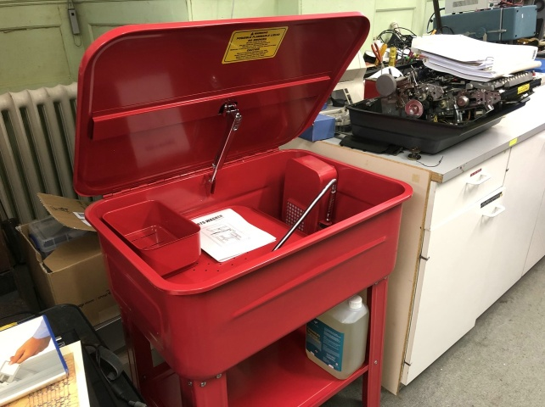

Curators have clubbed together and purchased a parts cleaner. Whilst it is large enough to hold even the largest of our typewriters it will also be very handy for smaller parts. Forty year old IBM No.6 oil is rather more like Gloy adhesive, for those of us who remember the little bottles with the slotted rubber cap. It remains to be seen how well it tackles a Selectric I/O typewriter – first victim is visible on the workbench. The only caveat is the detergent doesn’t agree with aluminium, where it has to be washed off pronto.

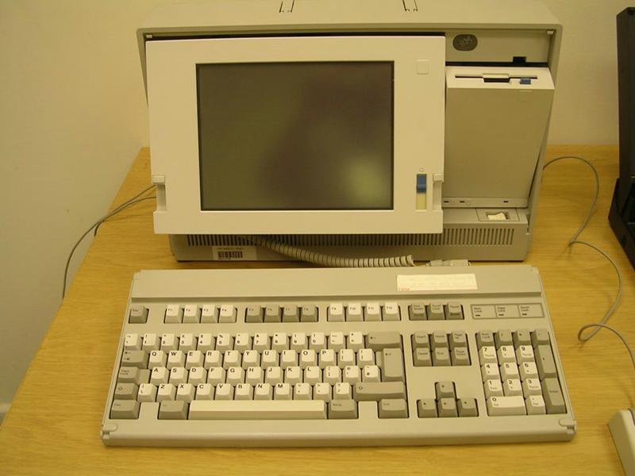

Our new curator has been working through our collection of PS/2 P70 portables and PC Convertibles, testing whether they are in working order.

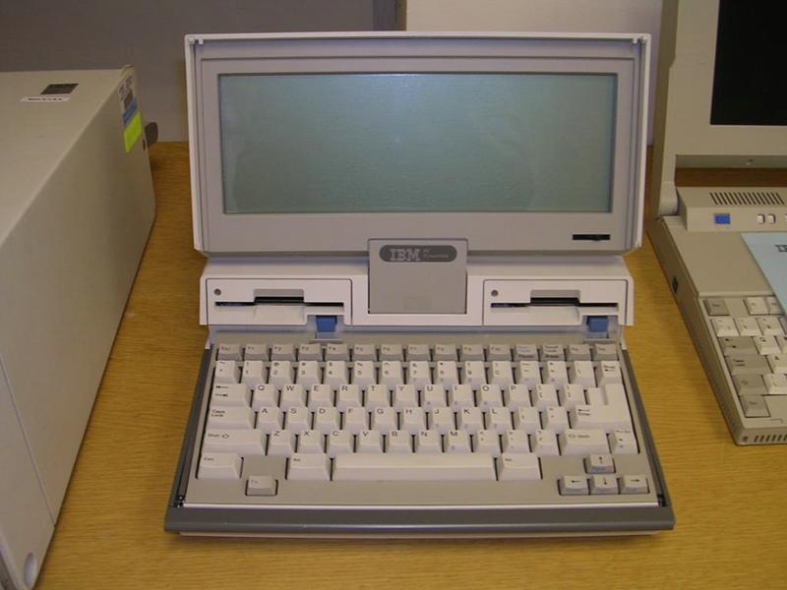

We do have more of these than we need, several working, and could donate to a worthy cause. If anyone is interested please contact Peter S.

I am hoping to get to see Jim Austin’s Computer Sheds this year, so we should be able to offer him one of each.

We continue to sort through thousands of photos and slides. All interesting hardware photos are scanned and will eventually arrive on the photo archive website. We are in discussion with Hursley about what to do with these photos once scanned.

This week marks the very final withdrawal of IBM from Greenock, with employees at the Pottery Street building moving to Glasgow. There’s a copy of the Greenock Telegraph report at <http://igonta.net/hursley/IBM%20Locations/Greenock/Greenock%20-%20The%20End%20May%202023/Greenock%20Ending.pdf> . A selection of photographs of the Greenock plant can also be found at <http://igonta.net/hursley/IBM%20Locations/Greenock/> .